Welcome
At
Van Engelenburg
Villas & More

General Information

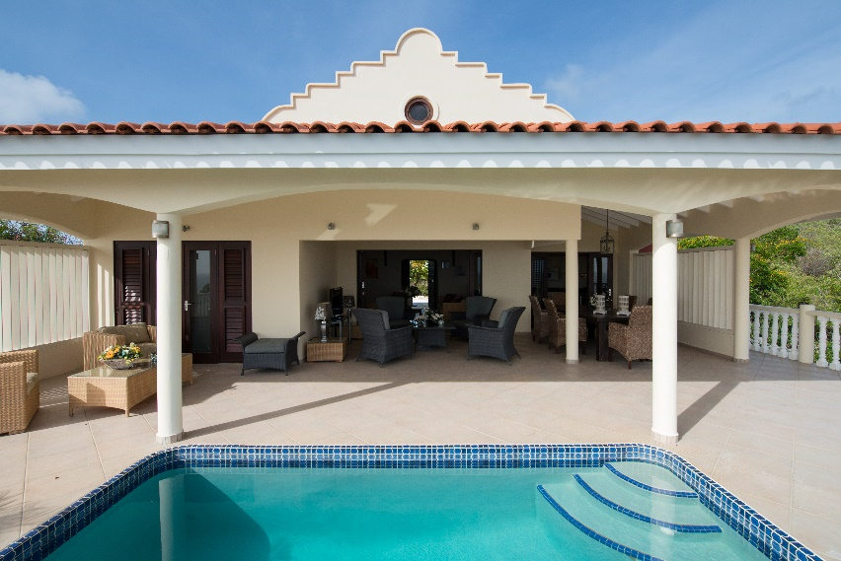
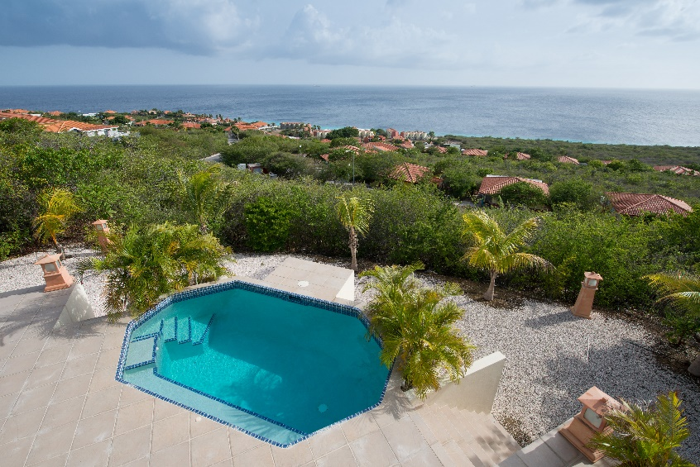

Van Engelenburg – Villas & More.

Office hours 08.00 – 17.00

Phone: 005999 694 10 26
Email: a.vanengelenburg@outlook.com
Web: www.vanengelenburg.co

The Wi-Fi password can be found on top or under the Router, in some villas this will be written in the information book from the specific villa.

Important phone numbers.

Ambulance: (005999) 912

Security Coral Estate (005999) 864 95 69

Doctor: Huisarts Spong, R. (005999) 864-870 / (005999) 510-2337

Flight information: (005999) 839 10 00

Police: (005999) 911

Fire department: (005999) 911

Road Service (005999) 9247

Dentist: (005999) 737 02 85

St. Elisabeth Hospital: (005999) 910

Van Engelenburg
Villas & More
Arrival at the Villa.
Personal check-in are: Mon to Fri. 08.00 – 17.00 Sat/Sun. 09.00 – 14.00
After closing hours, the key will be left at front-door of the villa, management will come and visit you next morning around 10.00, must you need us before then please call: 005999 694 10 26.
Before your arrival we would like to receive your flight information and the time you expect to be arriving at the villa. This can be mailed to the email address; A.vanengelenburg@outlook.com please provide your Name, date of arrival and the name of the villa you have chosen to rent.
Please always call 15 – 30 minutes before you are at the villa on the phone number; 005999 5222 730.
From here we will give you the last directions and meet you at the villa or the gate from the resort.
At the gate of the resort you must provide security with your full name and the Kavel number (Written in top of the Tenant Agreement) you will be staying at.
In case you have rented one of our rental cars, we recommend you take use of the taxis from the airport or our personal airport transfer.
In case you have a late arrival it is also recommended to order some groceries in advance.
Must we not be able to be there at the exact time you will be arriving, this will be handled and agreed in advance, we will make sure the keys are placed at a secure spot at the villa and the lights will be turned on. From here we will try to come and meet you so quick as possible at the villa in the meantime must you have any questions please feel free to call on the phone number; 005999 5222 730
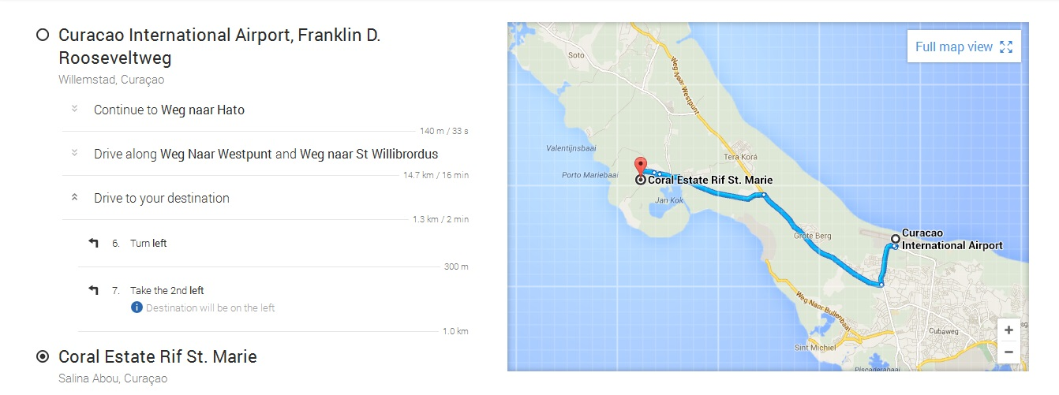

Our Services - Delighted To Serve You
Whatever the reason of your visit might be, we feel honored for your choice of Curacao!
For that reason we - Delighted To Serve You - will do our utmost to pamper and spoil you.
As exclusive on the island we offer you the following services in the Van Engelenburg Villas.
Transfer from and to Hato Int’l Airport.
Transfer during your whole stay to any place of your desire.
Unpack and packing of your luggage.
Groceries shopping.
Indoor Cooking and Serving.
Continental Breakfast, Brunch and/or diner.
Picnic on the beach.
Laundry and freshening of the Villa.
Change of bedding and towels.
Babysitting.
All these services for reasonable prices. If you are interested in one of the above mentioned, feel free to mail us so we can provide you with detailed information about the pricing and how it all works. We can provide you with our menu as well.
The following activities can be arranged for you with the best people on the island.
A Guided Tour.
Relaxation massage with miracle oils.
Diving, snorkeling.
BBQ Boat Trip to Klein (little) Curacao.
Sensational Sailing.
If so desired, we will take care of the music of your choice, Lounge, Jazzy, Salsa, Steel band or any other will accompany you while enjoying your cocktail and the sunset on your Terrace.
If there is anything else you wish and is not mentioned, don’t hesitate in asking. Ask for your wishes, desires, questions, suggestions in a mail to the address; Delightedtoserveyou@gmail.com
About the Villa.

When arriving to the property one of the crew members from Van Engelenburg Villas will be waiting to welcome you and your guest. They will tell you about the main use of the equipment in the property and about the surroundings of Curacao.

Once a week we stop by every villa to make sure everything is fine. May you not be there we will not enter the property in case agreed with tenant.
DEPARTURE:
Check-out is at 10:00 hrs. (10 a.m.) Assuring we have enough time to clean the house before the next guests arrive. Later
Check-out times may be arranged with prior notice and availability.
Final cleaning is included in rental cost, but tenants are responsible to leave the accommodation clean & in good state.
Kitchen appliances, refrigerator, pots & pans, dishes and counter-tops should be left clean.
Place trashcan outside the gate on Monday nights for pick-up Tuesday.
Leave wet towels hanging to dry.
An extra cleaning fee may apply if the property is beyond usual clean-up state and
not returned in an acceptable manner.

Keys not returned incur USD $65/key replacement charge.
CAPACITY OF THE ACCOMODATION
The number of persons stipulated in the rental agreement may not be exceeded and taking along extra beds, tents, caravans, etc., is not permitted. If the number of persons permitted to spend the night is exceeded, upon your arrival or during your stay, you will be at risk of access being denied or you may be asked to leave.

RESPONSIBILITY OF TENANT:
We ask that you adapt your way of living to local customs and conduct yourself in a demeanor fit for this upscale Neighborhood on Curaçao. Peace and tranquility is valued at the resort and quiet hours start at 22.00.
The villa is situated in one of the most beautiful places in the South-West coast of Curaçao, in Coral Estate, Rif St. Marie, where freedom, peace and quiet are key words & vital. Loud parties and noises are frowned upon.
Approval by owner is required for entertaining parties with more than 6 people involved.
Tenant is responsible for the rented accommodation and its inventory during rental term and will be held responsible for damages and/or items that are removed from property by tenant or its fellow house guests during rental term.

Declare to Adhere to General Provisions and Statues of Coral Estate:
4.7 Noise pollution / nuisance:
The Coral Estate Tenant undertakes to perform or to allow no harmful or annoying activities (nor to cause any such activities to be performed or allowed) which may annoy or inconvenience local residents, and to refrain from any activity that might cause nuisance
4.9 a. Pets:
Domestic animals may not be kept in the Resort, other than:
Dogs, a maximum of two per plot;
Cats, a maximum of four per plot;
(Domestic) animals may not run free on or in the common grounds and facilities. Pet droppings shall be cleared by the
Tenants of these animals.
b. Hunting prohibition:
Animal hunting in any way or form is prohibited in the Resort.
4.11 Traffic rules: All traffic rules prescribed or to be laid down by government for traffic on public roads shall apply correspondingly within the Coral Estate Resort; the maximum speed on the access roads shall be fifty (50) kilometers per hour, and the maximum speed on the built-up parts shall be thirty-five (35) kilometers

DO NOT PUT ANYTHING IN THE TOILET OTHER THEN TOILET PAPER otherwise the toilet system will get clogged and will not be usable

The pool pump will be damaged if you enter the pool with sand from the ocean. Please shower off the sand first before entering the pool.

DAMAGES:
We expect that you will use our home with care, as you do with your own home. Nevertheless, an accident can happen and something may be broken or damaged. We would prefer to affect timely repairs to ease any inconvenience to you or the next group of guests. Therefore we strongly request that you inform the property manager or owner at once of any accidents or repairs that may be required. Any damages beyond $30.00 are your responsibility and will be taken out of your security deposit + 5% administration fee if a credit card is used.

Always may you have any question about what so ever please feel free to contact Van Engelenburg Villas for your assistance

Security:

Coral Estate is one of the most secure resorts on Curacao, 24 hours per day there are security patrolling on the park and we have gated entrance.

Air-conditioning:

The property is equipped with air-conditioning in every bedroom, by every airco are one remote control with check in you will be told how to use the equipment.

Because electric is very expensive on Curacao we advise you only to use the air-conditioning when you are in the bedroom, extensive use of the airco’s will resolve in a high electric bill that may be deducted from your deposit.

We recommend:

Turn on the air-conditioning 15 min before you want to go to sleep.

Keep the temperature between 23 to 24, sudden change in temperatures can be dramatic.

Kitchen:

The kitchen is equipped with the most common used articles, please notice what kind of electric socket the specified equipment are using. Damage caused to the equipment will be deducted from the deposit.

Please do not place any hot item on the kitchen top plate, it may cause heavy burn marks. Also please always be careful working in the kitchen hot or boiling items needs to be observed.

Cook tops are mostly gas on Curacao. The flame will become smaller and smaller in case you run out of butane gas, must it happen through your stay please call the property management. Changing the bottles your self can be fatal

In case you may have any questions about using any of the equipment please contact the property management to assist you.

If the kitchen is left in a non-decent condition with check out an extra cleaning fee will be charged.

Swimming pool:

The property has its own private pool, and its deepest point is almost two meters deep. The pool will be cleaned once a week through the pool service crew from Van Engelenburg Villas, if you have any troubles or question about cleaning please contact the property management for your assistance.

Do not use any chemicals of your own in the pool!

The pool is equipped with a light you will be told with check in how to turn on and off this light.

The pool pump will be running certain number of hours every day depending on the pool size and condition, this is necessary to keep the flow and circulation for the whole pool system

after a heavy rainfall the pool can turn a little bit green, this is caused by algae, mostly it is harmless to still use the pool, and normally it goes away by itself in between 2 to 3 days must you have any questions in case of this situation please contact the property management for your assistance

The pool is not intended to be used for cleaning diving equipment, most diving sites on Curacao have a place to clean your equipment in case not please use the garden hose or one of the showers in the bathrooms.

Swimming and using the pool are at own risk there are no lifeguard, so please always use the pool responsly and take if children are staying in the property or playing around the pool

Also we recommend you to be care full with the use of glass around the pool. There is a pool net placed at the property in case an item falls into the pool.

Water (HOT)

You can drink the water from the tap without any problem it is not necessary to be filtered or boiled before the water is drinkable. The water is not really cold directly from the tap so it is recommended storing some water in the fridge.

The property is equipped with a hot water boiler that you can use in the kitchen and the bathrooms. Please be careful the water can be extreme hot.

May you have any questions about the water condition on Curacao or the use of the hot water boiler please contact the property management for your assistance

Smoking:

For the convenience of all our guests, our smoking policy is clear: “Out of respect for all guests, current and future, smoking is only permitted outside”. Please take care for the risk of fire, as it can be dry and windy o Curaçao. Use the ashtrays provided and deposit your remnants in the trash bin, not in the yard. Do not use the floor tiles or walls to extinguish your smoke
DO NOT THROW CIGARETTE BUTTS, it is extremely dry, a fire can start immediately. This is extremely dangerous. Please put out our cigarette in an ash tray and make sure its 100% out.

Television and radio

Most properties is equipped with a television and radio they are fairly simple to use and have a selection of channels or connectivity too your mobile device. Remote controls for the equipment are placed in the living room, please use the equipment gently and do not change the settings on the unit, problems caused by non-properly use of the equipment will be deducted from the deposit in case you have any question about using these items please contact the property management for your assistance

Washing machine

The property are equipped with a washing machine, this you may use for free. In case you run out of washing powder this can be bought at any supermarket on Curacao.

They washing machine are fairly easy to use, please be gentle using the equipment and do not try pull the door open before it has finished its running program.

May you have any questions about using the item please contact the property management for your assistance.

With check out we ask you to leave all bed linings and towels decent on the beds and in the bathrooms. If not an extra service for cleaning will be deducted from the deposit.

We recommend you to wash all you towels and bed linings one time per week, you may feel free to contact Van Engelenburg Villas for more information about your weekly cleaning and washing service if you would like it to be taken care of.

Garbage

The trashcan outside of the house will be emptied every Tuesday morning please make sure to bring the green container at the end of the driveway to house Monday evening, if it is placed at the house it will not be emptied.

Also please make sure that the garbage is placed in bags before it is put the green container.

Floors

Most properties have tiles on the whole floor, please be careful if those are wet they may be extreme slippery and can be hazard. We recommend you to dry up any wet spots, for your own safety.

Cleaning

The property will be handed over to with check in, in a clean and fresh condition we ask you kindly to do normal cleaning and keep our property in a good condition, may you have interest in a mid-week cleaning our cleaning service crew from Van Engelenburg Villas are able to help you with that please contact the property management for more information.

With check out it is required that the property are left in a decent condition, if not an extra cleaning fee will be deducted from the deposit.

Garden

Most properties have a larger garden with exotic plants from Curacao. The gardens are being taken care of by the Garden service crew from Van Engelenburg Villas. Please do not begin cut any plants or trees in the garden, also do not forget that customs have a very strict policy on Curacao which means almost every naturally item are illegal to export from the island. May you have any further question about the garden surrounding your villa, please contact the property management for your assistance.

Barbeque

Every property have BBQ equipment, please be extremely careful with the use of these, through dry seasons fire hazard are big on Curacao, also depending on where the BBQ are placed please to not move it. Hot burning coals may cause a big damage to the property and extended repair job. When checking out from the property the BBQ must be left cleaned if not an extra cleaning fee will be deducted from the deposit.

Bed linings and towels

With check in you will be giving a certain amount of towels and bed linings depending on how many people are staying in the villa. You may clean these yourself though your stay by taking use of the washing machine or if you would like Van Engelenburg Villas can take care of it and bring you new towels and bed lining one time every week for every person through your stay.

Garden furniture’s.
We ask you kindly to use a sort of towel on the furniture’s just right after taking use of the pool or shower, damage caused by water or similar to the furniture’s will be deducted from the deposit .

Your personal trip advisor on Curacao
At Van Engelenburg Villas our main goal is to make sure you have a dream vacation here on beautiful Curacao. Due to our extensive knowledge of Curacao, we are able to provide you with extra services that will ensure you'll have an unforgettable time on our paradise island.

Private guide – At Van Engelenburg Villas, we want our customers to feel happy, If you have any questions during your stay, we do our best to answer them within a short amount of time.

Holiday villas on Curacao – Are you looking for a holiday home in
Curacao, with a lot of privacy and space? We offer a selection of spacious private vacation homes. With private pool, Jacuzzi, panoramic view, private parking, barbecue, refrigerator with ice machine and Ideal Ocean front location. We offer it all! The villas and apartments in our rental pool are selected with great care. Each has its own house elements, benefits and competitive prices.

If you are interested, we can provide you with personal guides, fluent in Dutch, Danish and English. They can show you some amazing natural areas, off the beaten path or plan a day full of activities for you and your family.

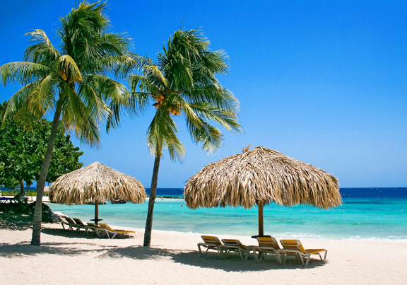
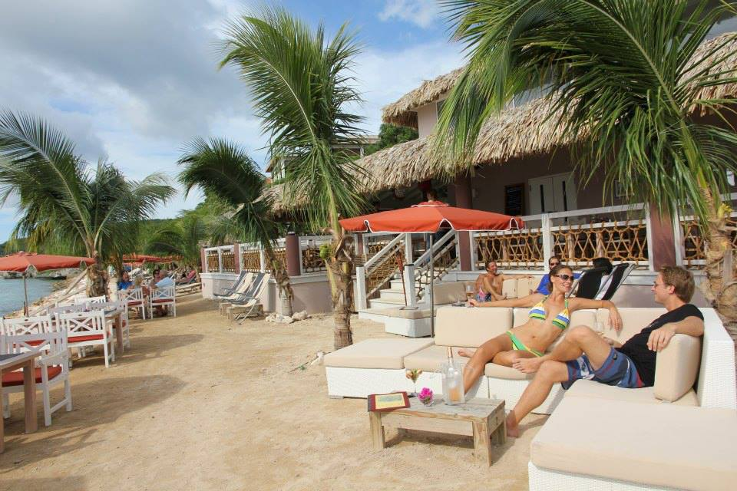

Curaçao History.

Straight To The Heart
What makes Curacao special among Caribbean islands? Authenticity. For centuries, we have forged a vibrant and rich culture rooted in history and hospitality. Our heritage is both European and African – representing more than 50 nationalities. We speak Dutch, Spanish, and English – as well as a local language, Papiamentu, a colorful Creole dialect.

Exploring Undiscovered Curaçao
The best part of exploring Curaçao is that it feels undiscovered, like an exclusive hideaway. One of the tiny “ABC Islands” – Aruba, Bonaire, and Curacao – this secluded slice of paradise is the Caribbean’s best-kept secret. The Curacao tourism board wants to help you uncover its many wonders. There are no “tourist traps” here. Locals and visitors mingle in harmony throughout the island. Relax and unwind amidst Curacaoäns working, playing, and enjoying life to its fullest – the same as they have done for generations. We love to socialize, so don’t be surprised if someone waves and tosses a friendly “Bon Bini!” (Welcome!) Or “Kon ta bai?” (How’s it going?)

A Fascinating Historical Heritage
The island of Curaçao was discovered by the Spanish in 1499 by Alonso de Ojeda, one of Christopher Columbus’ lieutenants. There are different explanations for the origins of the word Curaçao. The most likely is that the Spanish called the island “Corazon” (heart) at some point. The famous Portuguese mapmakers of the time adopted this word into their own language as “Curaçau” or “Curaçao.” Today, the locals know the island as “Korsow.”
The island remained Spanish until the Dutch conquest of 1634. In the 17th century, the Dutch became leaders in the international slave trade. Africans were enslaved from their homeland and transported to Brazil and Curaçao -- where they were sold to wealthy plantation owners from across the Americas. At that time, Curaçao was one of the largest slave depots in the Caribbean. Today, however, the slave site is home to the Kura Hulanda museum, a remarkable exhibition on the horrors of the transatlantic African slave trade.
From the end of the 17th century to the beginning of the 19th century, there was a good deal of trading places between the British and the Dutch, with the French also trying to take over the island. The French came close to succeeding, but left after extorting a healthy ransom. In 1815, the Dutch regained control of Curaçao, which had been in British hands since 1807. It wasn’t until the 1920’s and 1930’s that the largest influx of worldwide immigrants came and turned the island into the multicultural melting pot that it is. The “colonial” status of Curaçao and the other islands of the Dutch Antilles changed in 1954, when the islands became completely self-governing within the Kingdom of the Netherlands.
Over the years, the interaction between the Indian, European, African, Asian, and Arabic cultures has influenced and brought about the development of Curaçao’s unique society.

What about the name?
There are different theories for the origins of the word Curaçao (pronounced kyur uh sow). The most likely explanation stems from the Spanish calling the island "Corazon" (Heart) at some point. The famous Portuguese mapmakers adopted this word into their own language as "Curaçau" or "Curaçao." Today, locally, our island is known as "Dushi Korsou" (Sweet Curaçao).
Curacao Weather and Landscape

Geology and geography
Curaçao is divided in four geological units: the Curaçao Lava Formation, the Knip Group, the Middle Curaçao Formation, and the Limestone Formation.
The oldest known rock on our island is the Curaçao Lava Formation. It's a 5,000-meter-thick succession of submarine basalts, formed in deep waters in the mid-upper Cretaceous. The Knip Group formed in the upper Cretaceous ages and consists of siliceous sedimentary rock. It's noticeably thicker on the northwestern part of the island than in the southeast. The Middle Curaçao Formation is found principally in the middle section of the island. Its turbidity sequence, formed in the upper Cretaceous and or Paleocene age, consists of fine-grained conglomerates, mudstones, sandstones, and shale’s. The Limestone Formation can be divided in two units -- the Seru Domi formation and the Quaternary limestone terraces. The Seru Domi Formation basically formed as a sub-marine reef talus slope, and the Quaternary limestone terraces were formed by sea level changes combined with tectonic uplift.

Landscape
At first glimpse Curaçao may seem a rather barren island. Due to the scant rainfall, there is certainly a limit to the types of plants and animals that can survive here. But on closer inspection, you'll be amazed at the variety nature has to offer. What at first seems to be a monotonous desert landscape turns out to be terrain teeming with life. Curaçao's total surface area is 444 square km. The stretched northern coast of the island is characterized by rough limestone cliff formations set on top of eons-old volcanic rock and weather-beaten terrain. At the western end of the island you will find expansive, hilly landscapes. The Christoffel Park encompasses most of the landscapes. Inside the park you will find the highest point on the island -- the 375-meter-high Mt. Christoffel. The east end of the island comprises flat and mostly barren plain, with few settlements and some secondary roads weaving to and from its coastal inlets.

Flora
Local plants have ingenious mechanisms allowing them to weather the dry, desert climate, scant rainfall, and the ever-present trade winds. These include marvelous adaptations to their roots, leaves, and stems. Total vascular flora amounts to about 450 species. Species composition differs significantly between the different geological formations. No group of plants is as well suited to the climate as the cacti, which are specially designed to reduce the amount of moisture lost to evaporation. Their nasty thorns are, in fact, modified leaves.
One plant you have to avoid contact with is the manzaliña tree, called manchineel in other parts of the Caribbean. This tree has rough, dark bark and small green leaves. The fruit of this plant is poisonous, and will cause skin irritations and burning if touched. One of Curaçao's most characteristic trees is the Dividivi tree -- recognizable by its "wind form," caused by the trade winds.

Preserving Curacao’s natural beauty
Helping to safeguard Curacao’s natural splendor is CARMABI – a local foundation that conducts research and conservation. CARMABI manages different natural reserves such as the well-known Christoffel Park and Shete Boka National Park. Activities and projects are organized in these parks to support sustainable development. CARMABI also implements an environmental education program for different levels of the local primary and secondary schools. For more information, visit www.carmabi.org.
Practical information Curacao.

Gas Stations:
We recommend you to pay with cash ( NAF or U.S Dollars) at every gas station, there are two sorts, unleaded gasoline (yellow handle) Diesel (black handle) please do not forget it is necessary to pay before you can refill the car.

Electric:
On Curacao there are two types of power supply 110volt (American sockets) 220volt (European sockets) you may need a couple of adapters for you electric equipment, please make sure your equipment can be used on the chosen power supply before use.

Money & Currency:
You can pay cash on Curacao with Antilleans Guilders or US Dollars. Euros are mostly not accepted, Major credit cards are accepted almost everywhere on the island.
ATM machines can be found all over the island at major population centers and at the airport. To recognize an ATM machine, look for the signs “Bankomatico” or “Geldautomaat.” Most ATM‘s offer the option to withdraw in local currency or US dollars. 1,- Ang. = 0,55. US Dollar / 1,- US Dollar = 1,75. Ang.
Supermarkets:
The shelves of Curaçao's supermarkets and specialty food shops are well stocked with a variety of goods from around the world, and also some local products. Because of its prosperity and role as a major Caribbean transshipment center, Curaçao imports virtually all the food that is consumed locally. Supermarkets carry European, American, and South African products.

Centrum Supermarket Piscadera
Phone:+(5999) 869-6222

Esperamos Supermarket
Phone: +(5999) 868-1473

Mangusa Supermarket
Phone: +(5999) 737-6271

Albert Hein Supermarket

Phone: +(5999) 461-2411

Language:
The original language from Curacao is Papiamento it is used but almost every local, and is a mix of Portuguese, Spanish, Dutch and English. Although most people also speak Dutch, Spanish and English.

Some words and phrases in Papiamento:
- Please. – Por fabor.
- Thank you. – Danki.
- Ja. – Si.
- No. – No’.
- Good morning. – Bon Dia.
- Good afternoon. – Bon Tardi.
- Good Evening. – Bon Nochi.
- Goodbye. – Ayo’.
- Have a nice day. – Pasa bon dia.
- How are you? – Kon ta bai.
- Good. – Bon.
- Bad. – Malu.
- I don’t speak any Papiamentu. – Mi no ta Papiamentu.
- How much does it cost? – Kuanta e ta kosta?
- What did you say? – Ablif?
- Sorry. – Despensa.

Weather:

Curacao has a tropical climate with a breeze of Passat winds these also give a delightful cool and refreshing feeling, this also means a lot of sun and almost no rain. The average annual temperature are around 27,5C and the difference between summer and winter are only 2.5C also the difference between night and day are only around 5,0C the ocean temperature are around 26,8C average falls about 50 to 75cm rain per year, the most rain falls in the months October, November and December. The hottest months are August, September and October. The winter period are January and February (29,0C)

Curacao is mostly placed outside the area from hurricanes, but it can accrue during a storm of hurricane please:

- Stay inside.
- Close all doors and windows.
- Use only the phone for emergency calls.
- If the situation gets critical stay at the most safe place inside the house and stay away from doors and windows.
- Stay under some kind of protection in case of pieces falling.
- Listen to the radio or try getting connection to the internet for information.

Types of Curacao Clothing to Wear
Since temperatures are warm throughout the year, light, casual tropical wear is in order. When spending time outside, protect yourself from the sun. As most indoor establishments are air-conditioned, you may need a lightweight jacket or long-sleeved shirt. Locals dress fashionably, particularly for indoor evening events; Curacao fashion for outdoor festivals is decidedly casual. The strong trade winds may make wrap-arounds and billowing skirts a problem. Some restaurants prohibit shorts or sandals; some casinos also require jackets for men. Overly revealing clothes and bathing suits are not appropriate, except on the beach. Even though it’s not common use, nor accepted everywhere, you may see European visitors sunbathing topless.

Curacao Time Zone
Curaçao is on Atlantic Standard Time, one hour later than US Eastern Standard Time (the same time as Eastern Daylight Savings Time) and four hours earlier than Greenwich Mean Time.
During the summer, Curaçao has the same time as some of the cities in the U.S. but during winter, the time changes again to one hour later. In summertime, in Amsterdam it’s 6 hours later than in Curaçao, but during winter it becomes 5 hours. So, during winter, when in New York it is 9:00 am, in Curaçao it is 10:00 am and in Amsterdam it is 3:00 pm.
Water:
Curacao has some of the cleanest drinking water in the whole world, due to a special installation that cleans seawater into pure clean drinking water, this way of making drinking are very expensive, due to that water is on Curacao high priced.

Curaçao Auto Laws:
Driving takes place on the right-hand side of the road. At intersections and traffic circles, yield to traffic coming from your right unless signs indicate otherwise. At all T-crossings, through-going traffic has priority. The speed limit is 45 km/hour in town and residential areas, and 60¬-80 km/hour outside the city and on the four-lane Ring Road. Most gas stations are full service; a few are open 24 hrs.
To drive in Curacao, a valid driver's license is necessary. An international driver's license is not required.
Ask your car rental agency what you should do in case of an accident. Usual procedure is to call the car rental agency, and once they arrive at the scene, call Curaçao Road Services — you may have to file a police report. The Curaçao Road Services is available 24-hours a day, including holidays. In case of car trouble, call Roadside Assistance 24/7 Curaçao — they are at your service 24-hours a day as well.

Curaçao Road Services
Tel. +(5999) 747-1333 or 199.

Roadside Assistance 24-7 Curaçao
Tel. +(5999) 9-24-7

Tipping:
Giving a tip is something we do to show our appreciation and gratuity for rendered services. We truly hope you will tip well, for this will mean you love your stay on our island! It is suggested to tip the porters at the airport Nafl.1 per bag. Taxi drivers are usually tipped with 10% of the fare. Restaurants usually add 10% and most hotels a 12% service charge to the bill. Hotels charge an additional 7% government tax. Please note that these are not tips. Of course, tipping is left to your own discretion at all times.

Communication:
Curaçao's international code is 005999; there are no internal area codes. All local telephone numbers are seven digits, except for some special numbers, which are three or four digits.
Whether you’re on Curaçao for business or for pleasure, you’ll appreciate the value of mobile communication from a cellular phone. If roaming is not available with your local network, you can either opt for a rental cellular phone, or buy a pre-paid chip and number for your own phone.

Medical Facilities:
Curaçao has the most modern hospital in the southern Caribbean, with a decompression room and facilities for major surgery.

Curaçao Hospitals:
St. Elizabeth Hospital
Phone:+(5999) 462-4900
Emergency phone: 910
E-mail: info@stelisabethhospital.com

Dental clinics:

Centro Dental Mahaai
Sta.Rosaweg 28
Phone: (+5999) 737-0285
Fax: (+5999) 736-9033
Website: www.dentist.an

Other convenient Curacao health services
For minor complaints, over-the-counter medicines are found at a local pharmacy ("botika"). Most are open all day until 7 pm and some stay open 24 hours on a rotating schedule.

Rental cars from
Van Engelenburg Villas
Kia Picanto (Manuel)
Passengers: 4
Baggage:1
Price per day: $40.00,-

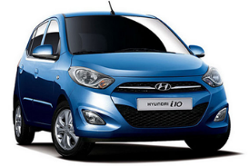
Hyundai I-10 (Automatic)
Passengers: 4
Baggage:1
Price per day: $40.00,-

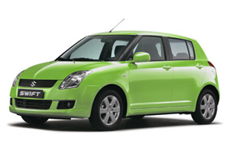
Suzuki Swift (Manuel)
Passengers: 5
Baggage:2
Price per day: $45.00,-

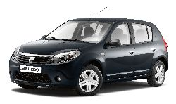
Renault Sandero (Manuel)
Passengers: 5
Baggage:3
Price per day: $45.00,-

Kia Soul (Automatic)
Passengers: 5
Baggage:3
Price per day: $55.00,-

Kia Carens (Manuel)
Passenges: 7
Baggage:4
Price per day: $60.00,-

Kia Sportage (Automatic)
Passengers: 5
Baggage:3
Price per day: $65.00,-

The Prices include: All cars are equipped with:
All risk insurance. Airco.
Accident insurance. Alarm.
24/7 Road Service. Radio/CD-player.
Free 2nd Driver. Highchairs for children: Free
Free mileage. Seat raiser: Free
Deductibles hull damage: $430.00,-
Excess liability: $285.00,-
The deposit is: $480.00,- All prices are Excl. 9% Tax

